LAB #08

Operational Amplifier Applications-Inverting Summing Amplifier and Difference Amplifier



Fall 2022

**CSE-203L CS 2 LAB**

Submitted by: MUHAMMAD SADEEQ

Registration No.: 21PWCSE2028

Section: C

“On my honor, as a student of the University of Engineering and Technology, I have neither given nor received unauthorized assistance on this academic work”

Submitted to:

Engr. Faiz Ullah

(12 Dec 2022)

Department of Computer systems engineering

University of Engineering and Technology, Peshawar

**OBJECTIVES:**

To demonstrate the use of Operational Amplifier for performing mathematical operations of summation and difference.

**EQUIPMENT:**

1. DC Power Supply
2. Oscilloscope
3. Function Generator

**Components:**

1. LM 741 Op-amp
2. 47kΩ
3. 100kΩ

**Part A**

**Inverting Summing Amplifier**

**Theory Overview:**

Figure 1 shows an example of how an operational amplifier is connected to perform voltage summation.

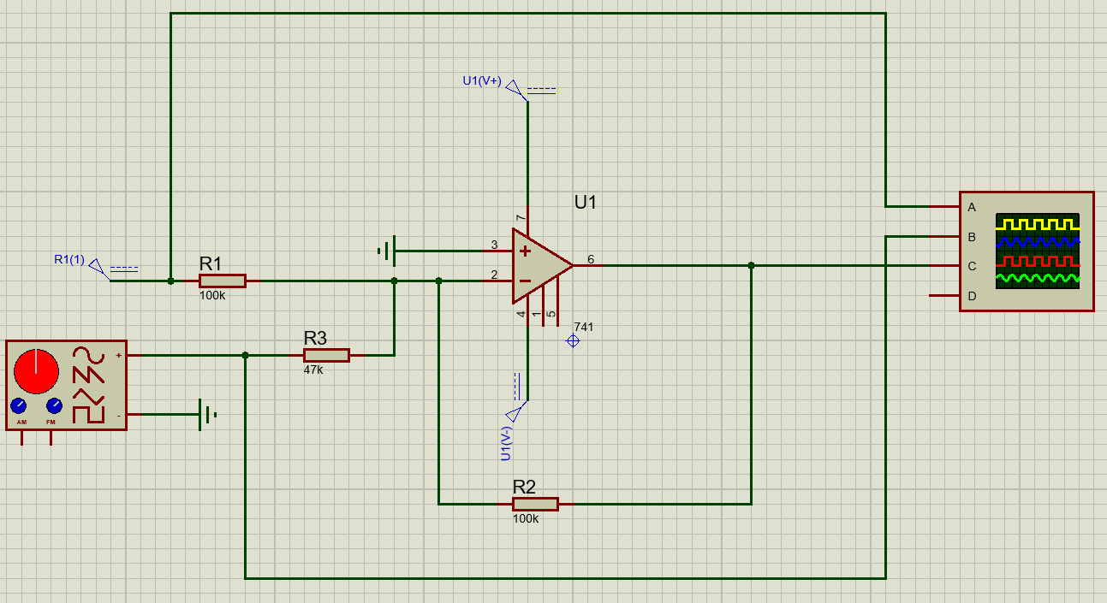

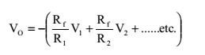

**Procedure :**

1. To demonstrate the use of an operational amplifier as a summing amplifier, connect the circuit of Figure 1.
2. With VS adjusted to produce a 1 V peak sine wave at 1 kHz, observe the output voltage VO (and VS to note the phase relationship) on an oscilloscope set to dc input coupling.
3. Sketch the output voltage waveform. Be sure to note the dc level in the output.
4. Interchange the 5 V dc power supply and the 1 V peak signal generator.
5. Repeat procedure step 2 and observe the change in output waveform.

**Part B**

**Inverting Difference Amplifier**

**Theory Overview:**

A difference amplifier has two inputs and the output voltage is proportional to the voltage difference of the input voltages. In fact, the (open-loop) Op-Amp itself is a difference amplifier, except that the gain is ideally infinity. Here we want a difference amplifier with finite gain. One such circuit using a single OpAmp is shown in Figure 4. It can be shown that the gain of the difference amplifier can be calculated using the following: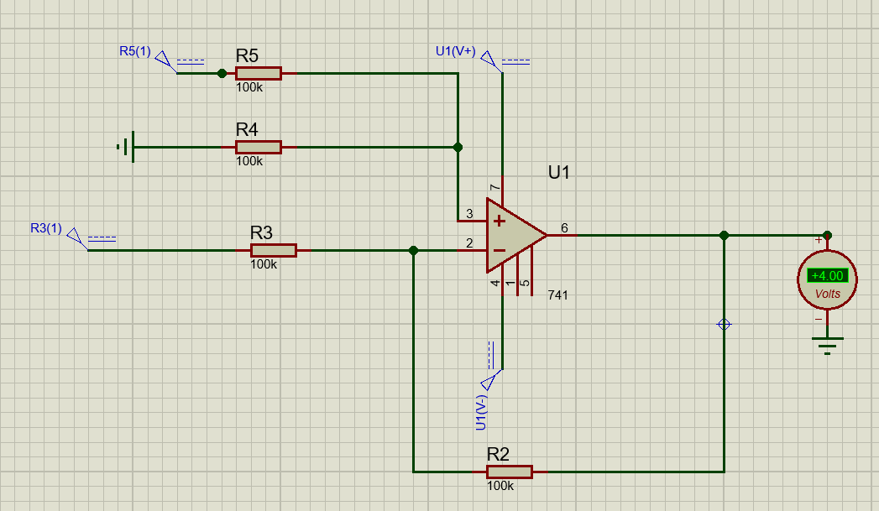

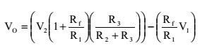

This equation can be simplified by making R3= Rf= R1= R2, yielding a simple differential amplifier with unity gain:

# V0=V2-V1

**Procedure:**

1. To investigate the use of an operational amplifier in a difference amplifier configuration, connect the circuit of Figure 2.
2. With V S adjusted to produce a 1 V peak sine wave at 1 kHz, observe the output voltage VO(and VS to note the phase relationship) on an oscilloscope set to dc input coupling.
3. Sketch the output voltage waveform. Be sure to note the dc level in the output.
4. Interchange the 5 V dc power supply and the 1 V peak signal generator.
5. Repeat procedure step 2 and observe the change in output waveform.